Asset Performance 4.0 hybrid Conference & Exhibition reveals full programme!

In only a few more weeks, the hybrid Asset Performance 4.0 Conference & Exhibition will be taking place! From 26 to 28 October, you get to learn how to take your assets to the next level through interactive workshops and insightfull presentations, brought by asset management experts.

Discover the full programme

On the first conference day, you can participate in your personal selection of the 20 workshops where you can get to work with innovative technologies and gain practical insights into asset performance.
This will be followed by 2 extensive days of presentations, kicked-off with keynote speeches by notable representatives of prominent companies in the world of asset management, such as Eriks, GE Digital, I-Care, SKF, Mathias Kuom (DG Connect) and Dr. Alexander Broos (VDW & umati).
Of the more than 70 presentations that we carefully selected and organised in 6 tracks, 25 are practical cases by industry experts:
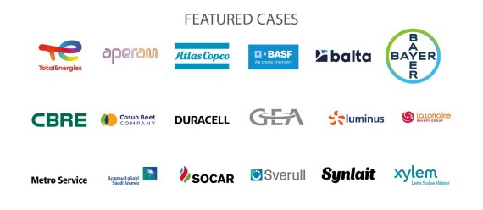
Register now!

